Assessment 3 – Doughnut Ordering System

**Doughnut Café**

# Proposal

An independent doughnut store located in the heart of Trafford an affluent location with huge customers existence. The Café is represented by their leader Ms. Jhon Hallam, who approached us to help to reinvent the company’s ordering system which really sets them apart from their competition.

The ongoing pandemic has significantly reduced their customers and having only minimal online presence the business is having troubles to survive. Their current method of accepting orders digitally is done via Telephone. Sometimes calls are missed, orders are prepared and kept aside for it never to be paid if customers don’t come to collect, also orders aren’t stored, and data collection is almost impossible. Customers can only pay with cash when they arrive to pick up their orders or when the delivery guy has reached their house if they did home delivery, meaning the risk of Covid-19 infection is high.

# System Design

Many problems found with the existing system, such as to place the orders customer needs to be present, check the menu, and chooses the items required, then places the order and then proceed with the payment, which demands more manual work and customers time When the customer wants to order over the phone, customer is unable to see the physical copy of the menu, this also lacks the verification that the order was placed for the appropriate items and customers’ address.

The new system begins with the customer entering their details (ID and password). Whenever that has been confirmed, the customer can put in a request determining the food and his amount required. Presently we get a window that shows the order number, customer ID, food name, cost and amount. When the customer finishes their request, they are diverted to the payment window where the absolute cost is shown, and the customer then can procced with the payment and afterward the customer gets a message of affirmation of request, and if you are an administrator, you can choose the typical login alternative and enter the administrator accreditations (ID and password). When you enter the administrator entrance, you get the choice of adding food, erasing food or refreshing food. Once the selected operation is carried out, the final product, for example the additional food or the refreshed food list is shown and in the event that you have erased a food, that specific food vanishes from the principal menu.

**ER Diagram**

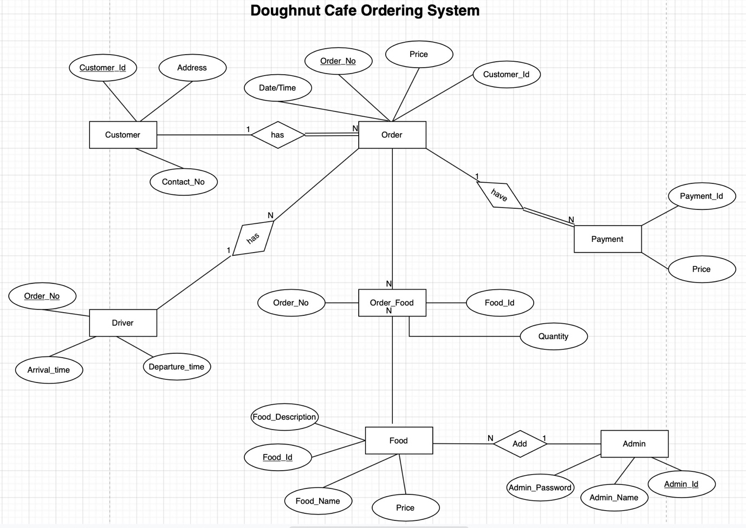

This system will help people to easily order food, it can ensure that people won’t waste their vital time, instead use in other work productively. We can ensure that this system proves to be more cost effective, user friendly, and is much more reliable than other systems. This system will also help to reduce labour cost as there aren’t any limitations as such in the system.